Fuzzy Logic
Fuzzy Logic helps work with situations where the information is unclear or partly true. Instead of only 0 or 1 like traditional logic, it allows values between 0 and 1 to represent partial truth. This makes it useful in real-world decision-making where data is not exact.
Key Concepts:
1.Membership Function:Defines how much an input belongs to a particular category
2.Fuzzy Sets: Sets where elements have degrees of membership
3.Linguistic Variables:Variables defined using terms rather than precise numbers.
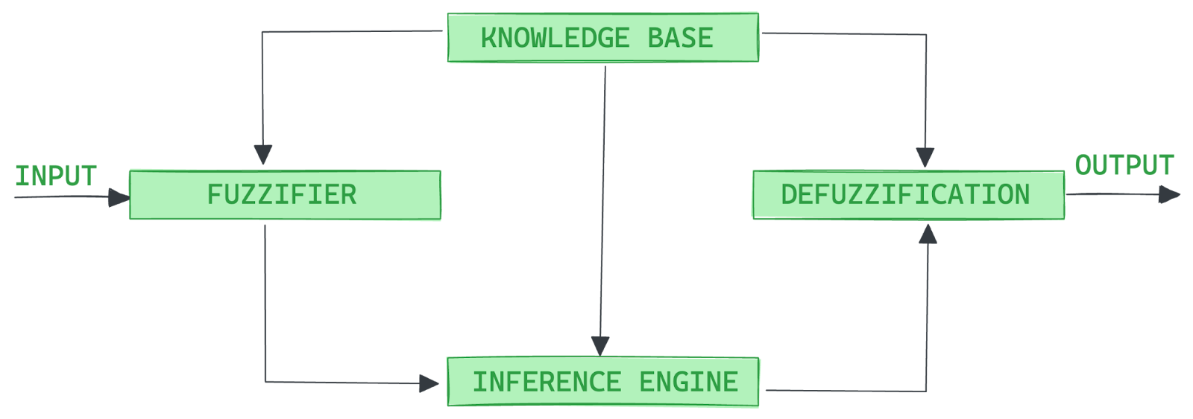
1.Fuzzification:converts precise values/input by sensors into fuzzy values using membership functions
2.Knowledge Base:contains a set of IF-THEN rules and membership functions provided by experts.Governs the decision-making process.
3.Inference engine:emulates human reasoning by evaluating degree of match b/w fuzzy input and Knowledge base (rules).
4.Defuzzification:transforms the generated fuzzy output(by inference eng) into precise values
https://www.datacamp.com/tutorial/fuzzy-logic-in-ai
USE CASES OF FUZZY LOGIC IN AI
1.Industrial Control Systems: Temperature and pressure fluctuate ,fuzzy logic provides smoother transistions.
2.Appliances and Electronics:Smart washing machines
3.Decision Support Systems: Stock market forecasting(strongly bullish,slightly bullish,stagnant)
4.Pattern Recognition & CV: Handwriting analysis
5.Game AI
Sources:
https://www.professional-ai.com/fuzzy-logic-systems.html
https://www.mdpi.com/2078-2489/15/10/656
https://ieeexplore.ieee.org/document/726786/#:~:text=Financial%20markets%3A%20very%20noisy%20information,IEEE%20Journals%20%26%20Magazine%20%7C%20IEEE%20Xplore
https://www.mdpi.com/0718-1876/19/1/7

TECHNIQUES OF IMPLEMENTING FUZZY LOGIC:
1.Token Sort Ratio: it is fuzzy string matching metric that calculates the similarity bw two strings by ignoring the order of words.
How it Works
The token sort ratio process involves several steps:
- Tokenization: Both strings are broken down into individual words (tokens).
- Preprocessing: Punctuation is removed, and all characters are converted to lowercase.
- Sorting: The tokens in each string are sorted alphabetically.
- Re-joining: The sorted tokens are joined back into a single, processed string.
- Ratio Calculation: The standard Levenshtein distance-based similarity ratio (a score from 0 to 100) is calculated between the two new, sorted strings.
example
- • String A: "Services Cloud Computing Amazon"
- • String B: "Amazon Computing Cloud Services!"

2.Token Set Ratio:Compares two strings based on the unique words they have in common,ignoring ordering and no. of repeated words.
How it works:
- Tokenization: The input strings are split into individual words or tokens. Punctuation is typically removed and capitalization is standardized (e.g., to lowercase).
- Set Creation: The tokens from each string are converted into a set, which automatically discards any duplicate words.
- Intersection and Remainders: The intersection (common tokens) and the remainders (tokens unique to each set) are identified.
- Ratio Calculation: The simple Levenshtein ratio (or similar string distance metric) is calculated between various combinations of the common and unique tokens.
- Score Selection: The highest ratio from these comparisons is returned as the final token set ratio score.

EG:
• String A: Amazon
• String B: Amazon Web Services Inc. Logistics Division

3.Partial ratio:computes the similarity between two strings by focusing on the best-matching substring, rather than comparing the entire strings from end-to-end.
Example: * String 1: "Order Number: 99821-X"
- String 2: "99821-X"
- Result: 100%
4.Levensthein Distance:measures the minimum no. of edits (insertions,deletions,substitutions) required to change one word to another.
• The Math: It calculates the cost of transformation.
• Example: To change "Kitten" to "Sitting":
- K $\to$ S (Substitution)
- e $\to$ i (Substitution)
- add g (Insertion)
- Distance = 3

